**September27th, 2025 "Spirited" Mountain Drive**

**to Spruce Pine, NC**

**•When:**Saturday, September 27th 2025. Meet at Harris Teeter Gas Station at Riverbend Village (3909 Corning Place near 16 and Mt Holly Huntersville Rd) starting at 8:30 am. Driver’s Meeting at 8:45 am. Depart at 9:00 am.

**•Where:** The exciting roads of the NC mountains.

**•Details:** A challenging drive from Charlotte through Morganton, Marion and traveling on 226A to Little Switzerland arriving at about noon in Spruce Pine for lunch at DT’s Blue Ridge Java Café (169 Locust St, Spruce Pine, NC). Then heading back home on Blue Ridge Parkway and 80 through Marion stopping at Dot’s Dario for Ice Cream (30 Lake Tahoma Rd, Marion NC). Other breaks / rest stops are planned along the way with a final stop at Redbone Willy’s at Intersection of 18 and 27 to say Adios!  
  
**•Contact Information:** The drive is limited to 20 cars. Text Dave Hurwitz to register, include your email address. For details or questions, contact him at 704-399-1108 or at [davehurwitz@earthlink.net](mailto:davehurwitz@earthlink.net) .

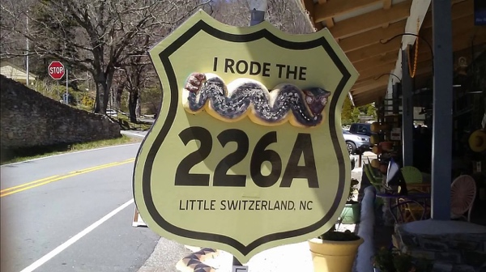 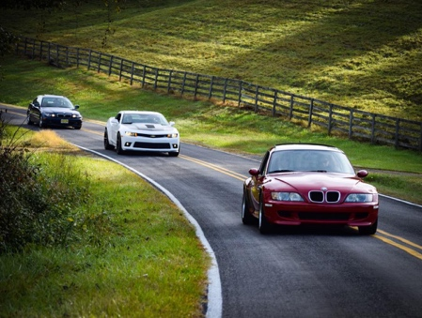 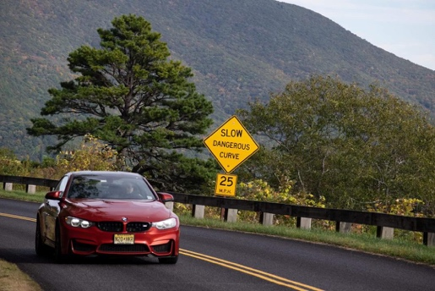

226A is an 11 mile stretch of twisties from 226 up to the Blue Ridge Parkway and then back over to 221.